**Mission 1:**

**Welcome**

**Student Workbook**





**What is CodeSpace?**

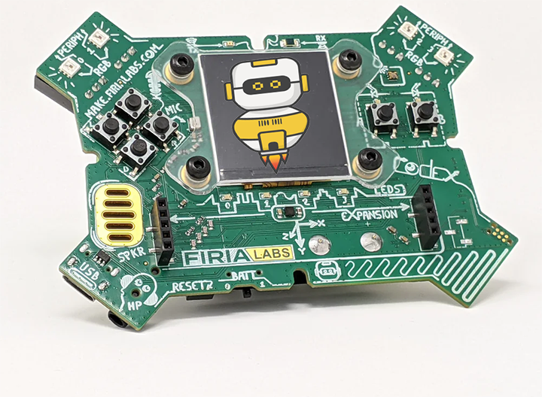

It is a programming development environment that includes a text editor, or a place to type code. After you type code, or instructions for the computer, CodeSpace changes the code to simple commands a computer can understand. The commands are sent to the CodeX, which is a physical device. Finally, the CodeX follows the commands.

For this mission, you will learn about CodeSpace.

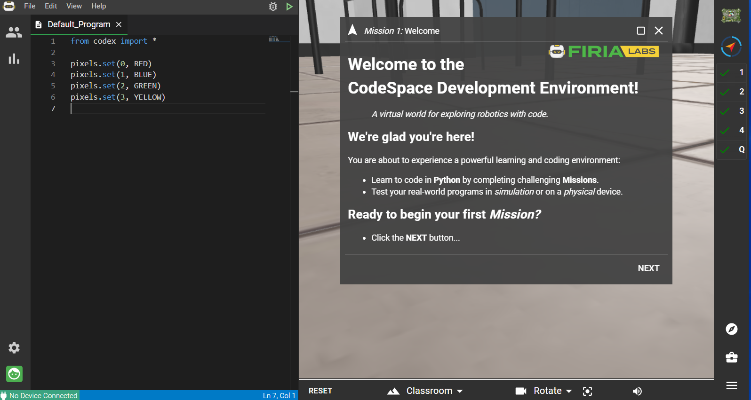

**Mission 1: Welcome**

1. Go to <https://sim.firialabs.com/> and log in.



1. Click to go Objective #1
2. Each mission has several objectives. The objectives are displayed on the right-hand side of CodeSpace, in a vertical panel.
3. Each objective has at least one goal to complete.

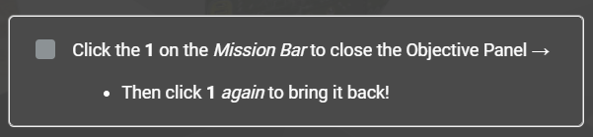



1. For the first goal, go to the objective panel and click on   
   Did you see the instructions disappear?



1. Click again. The instructions reappear. You can choose to see or hide instructions whenever you want.
2. Now your Objective 1 Goal is complete.

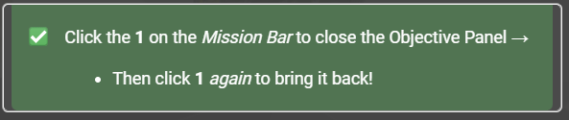



1. Click   
   

Read the completion message and notice the green check mark next to 1. Then click NEXT again.

**Objective 2: Text Editor**

The left side of the screen is the text editor.

This is where you type your code!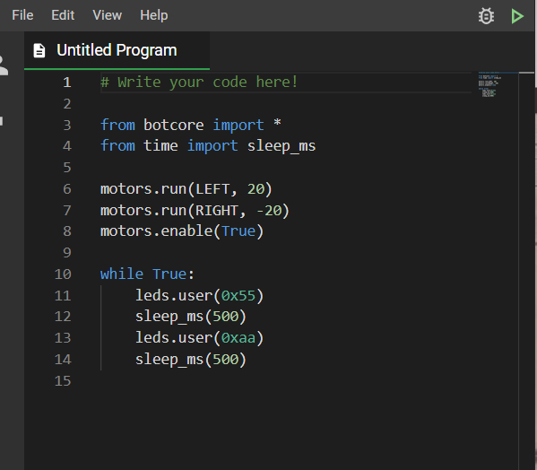



**Do this:**

Make a change to the code by clicking in the editor.   
Go ahead - click!

You can:

* change a number
* add a blank line
* change True to False

**Objective 3: The Coding Toolbox**

  
On the lower right side of CodeSpace, you see the icon of a toolbox:

Click on it!

Did you get a message that your toolbox is empty? You can add tools to your toolbox during each mission.

As you go through the instructions, you may see a word in blue with a wrench next to it.

Clicking on a **blue word** will give you additional information about the topic. This also puts the concept in your toolbox so you can go back to it later.

**Do this:**

* Click on in the instruction panel
* Read a little about debugging, and then close the panel
* Click on your toolbox. Do you see debugging there now?
* Whenever you see a term in blue, you can click on it to add it to your toolbox.

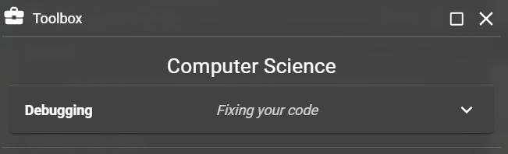

**Objective 4: Simulation Controls**

You can change the camera view in the simulation area. You won’t need to do this very often, but knowing how to will come in handy for some of the objective goals.

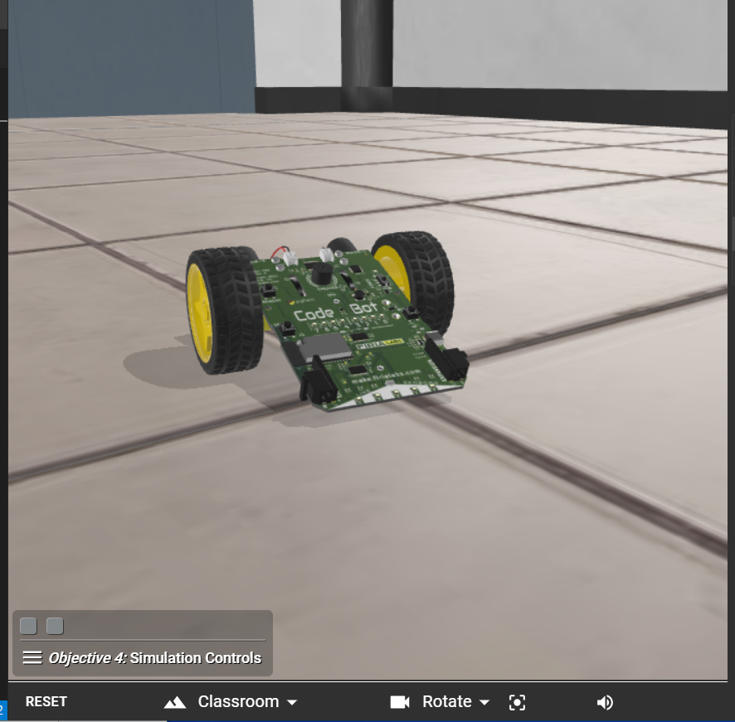

**Camera control**

**Do this:**

* Close the instruction panel (you can click on 4)
* Click on the triangle to open the camera control
* Click on *Help* to read how to control the camera
* Close the help panel
* Rotate the camera view so the scene goes around a couple of times
  + - * Both goals should now be met



**Your first mission quiz**

You have learned a lot about CodeSpace! Answer these two questions about the mission.

**Do this:**

* Read your “Completed Mission” message
* Complete the Mission 1 Log
  + Post-Mission Reflection
* Get ready for your next mission!